Science Olympiad
Fozendog’s Practice Test
Dynamic Planet
Test

Name the type of glacier shown in each picture:

- This glacier can be classified as two types, name each one:
____________________ & ___________________________

- This series of photos shows a glacier over 30 years. What type of glacier is this? __________________________________________________

- What type of glacier is this? _______________________________________________

- What type of glacier is this? ______________________________________________

- This is one of the only land masses that has these: ____________________

- This is what type of glacier? ______________________________________

- This is what type if glacier? ________________________________

Name the glacier feature in each picture:

- This is what glacier feature? __________________________________

- This is what glacier feature? ______________________________

- This climber is currently in what glacier feature? _______________________

- This is what glacial feature? ______________________________

- This image illustrates the formation of what glacial feature? _________________________

- The sides of this glacier show what glacial feature? ________________

- This is what glacial landform? _______________________________

- This is what glacial landform? ____________________________

- Name the glacial feature as well as this famous mountain: ___________________________

- Name this glacial feature: ___________________________________

- Name this glacial feature: __________________________________________

- Name each of the glacial features on diagram “19”:
A: __________________________
B: __________________________
C: __________________________
D: __________________________
E: __________________________
F: __________________________
G: __________________________

Name this glacial feature: ___________________________________________

Name this glacial feature: _____________________________________________

Name the glacial feature in the center of this picture: ________________

Answer each question on the answer key:

- The degree of ellipticity of Earth’s orbit around the sun is called:
- Precession
- Eccentricity
- Ellipticality
- Tilt

- If a glacier is moving quickly over a short period of time then it is a ______________________ glacier
- Rock
- Valley
- Falling
- Surging

- What feature forms when two glaciers merge together?
- Crevasse
- Horns
- Medial Moraine
- Arêtes

- Glaciers contain how much of the Earth’s freshwater?
- 30%
- 36%
- 25%
- 33%

Fill in the blank space with the correct answer

- In the __________________________________ snowfall is occurring all year round.

- In the ___________________________________ snowfall rarely occurs.

- The _________________________ separates the answer to question 19 and the answer to question 20.

- All the material dropped by a glacier is called ______________

- Glaciers erode the landscape by _____________ & ________________

- The stages from snow to ice are:
Snow
____________________
____________________
Glacial Ice

- The present epoch we are in now is ________________ and the one before the present epoch is the __________________ epoch.

- In the epoch that lasted from the beginning of the Quarternary Period to the end of the last glaciation there were 4 different major ice ages. Name them: _____________________________, ___________________________________, ________________________________, & ______________________________

- Concerning the previous question, the oldest of these ice ages was the _________________________________ ice age and the latest one was the _____________________________ ice age.

- The snow line at the equator is approximately ___________ meters

Match each of these glacial features to the type of glacier that forms it:

- Arêtes: ______
- Truncated Spurs: ______
- Continental Glaciers

- Valley Glaciers

- Both Valley and Glaciers
- Kettles: _____
- Eskers: ______
- Drumlins: ______
- Kames: ______
- Cirques: ______
- Horns: ______
- Hanging Valleys: ______
- Glacial Trough: ______
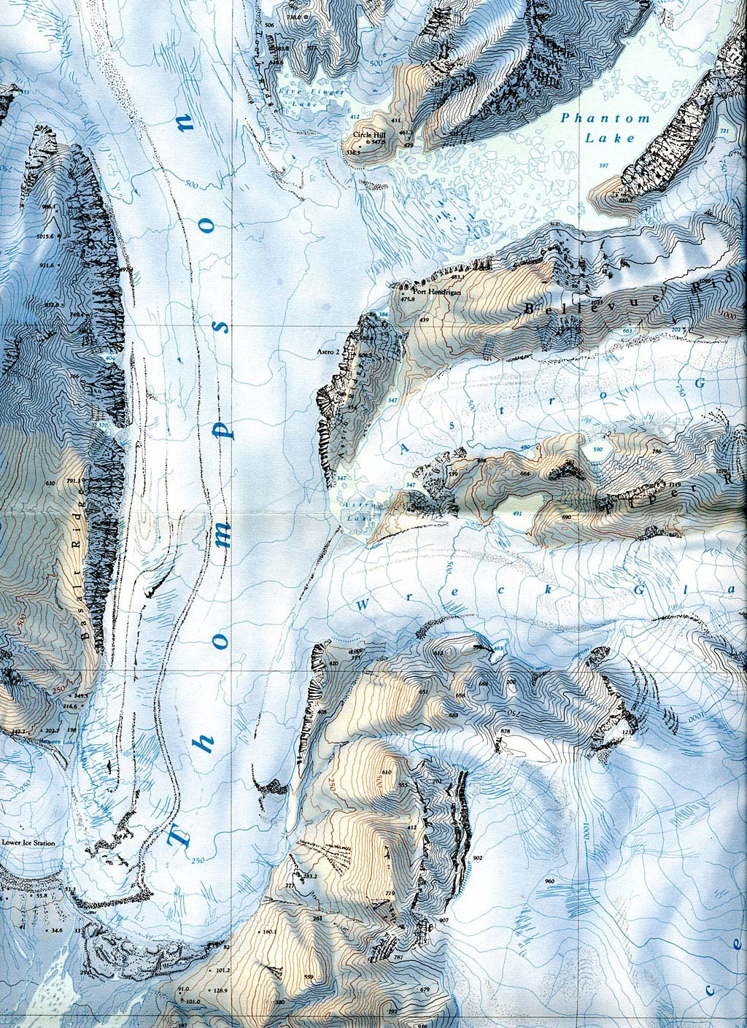
C
B
Topographic Map
A
Answer the following questions:

- Referring to the Topographic Map, what type of glacier is the Thompson glacier? ______________________________

- On the topographic map there is a circle with a letter A next to it. What glacial feature is in this circle? ______________________

- On the topographic map there is a circle with a letter B next to it. What glacial feature is in this circle? _________________

- When the Wreck Glacier and the Thompson Glacier meet what will be formed in the middle? ______________________

- What is the contour interval of this topographic map? _____ feet

- On the topographic map there is a circle with a letter C next to it. What type of glacier is in this circle? ________________________

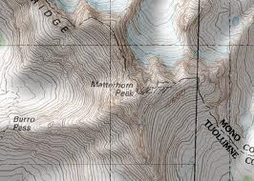
B
A

- Where is this famous mountain located? _______________________

- On this topographic map there is a circle with a letter A next to it. What glacier feature is in this circle? __________________

- What is the glacier feature in circle B? ______________

- What is this diagram of? _______________________
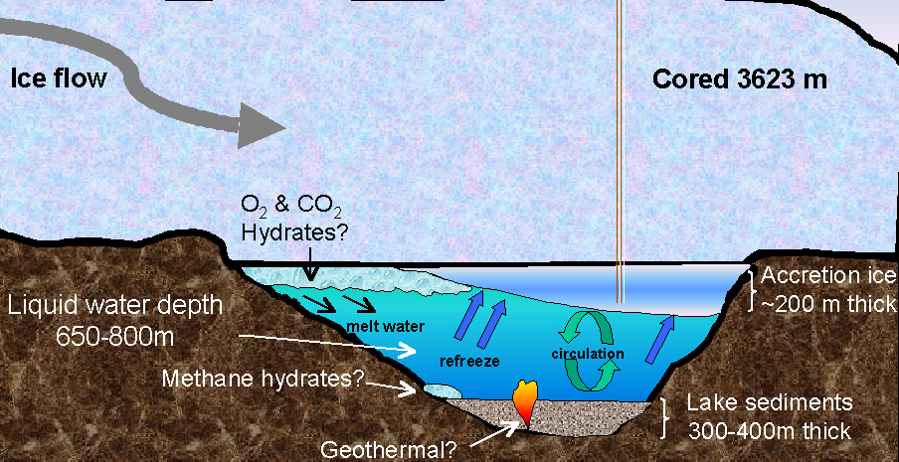
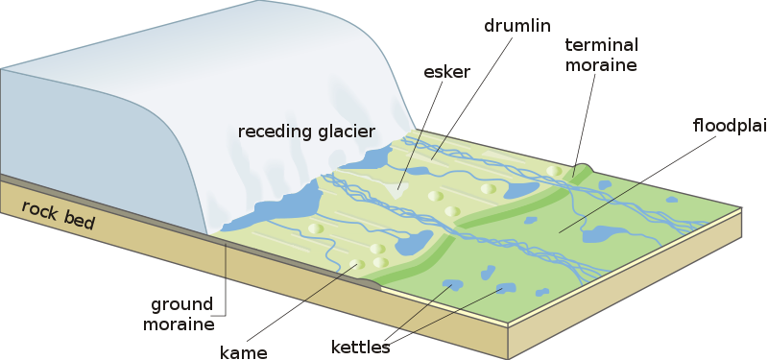
G
F
E
D
C
B
A

- Identify each of the glacial features in the above diagram.
A: _______________________
B: _______________________
C: _______________________
D: _______________________
E: _______________________
F: _______________________
G: _______________________

