FSA Invitational 12/11/10 Awesome Aquifers Station 2 Test
Do Not Write on Test Packet. Put all answers on the Score Sheet

Pam Walsh
12/11/2010

FSA Invitational 12/11/10
Awesome Aquifers Station 2 Test
Please record answers on team score sheet.

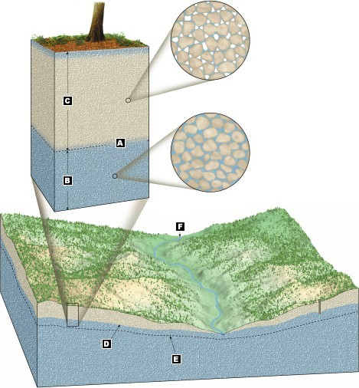

Indicate the correct response for the labels on the diagram:

____1. Elevation of the water table during dry periods.

____2. zone of aeration (infiltration zone)

____3. water table is at the surface

____4. water table

____5. Elevation of water table in wet periods

6. Since the highs and lows of the shape of the water table cannot be viewed directly, how do we use the topography of a region to determine that shape?

a. The shape of the water table is a flat, horzontal surface everywhere except in a few places where geysers bring groundwater closer to the surface.

b. The shape of the water table is a subdued replica of the land surface hills and valleys.

c. The shape of the water table is an exact replica of the land surface hills and valleys.

d. The shape of the water table is variable day to day depending upon the mass of the material the water is in.

Identify the features on the diagram:
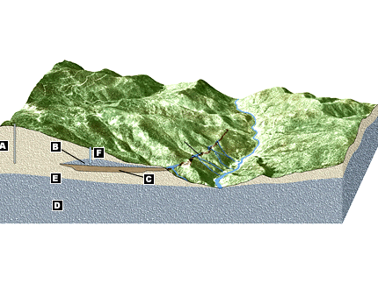
____7. Perched Aquifer

____8. Failed well

____9. regional aquifer

____10. aquitard

____11. successful well

Match the following “problem” associated with groundwater with its effect:

___12. highway salt and fertilizer a. sewage is released into the aquifer, and
subsequently into wells

___13. leaky septic tanks b.saltwater contamination of oceanic water in well

___14. excessive pumping in coastal areas c. new cone of depression could reverse the flow
of groundwater so that contaminant will make it
into new wells
d. surface runoff supplies contaminants to aquifer
recharge areas

