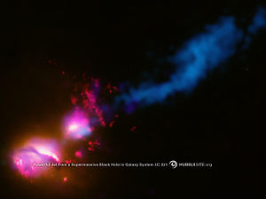 | 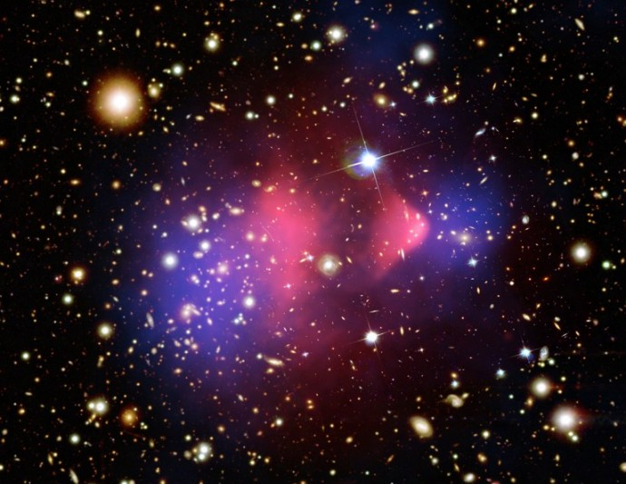
 | Bullet Cluster (1E 0657-56)
Death Star Galaxy (3C321) | Two clusters of galaxies 3.4 billion light years away. Blue is dark matter, red is observed x-ray gas. The dark matter was determined by observations of gravitational lensing.
Composite image. A jet from the supermassive black hole at the center of the bottom-left galaxy is blasting matter out of the upper-left galaxy. This blown off material is the blue cloud. 1.4 Billion Light years away.
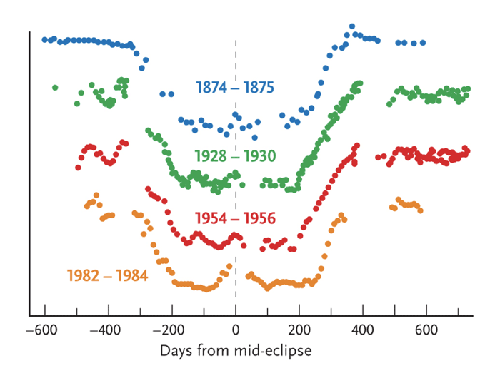 | 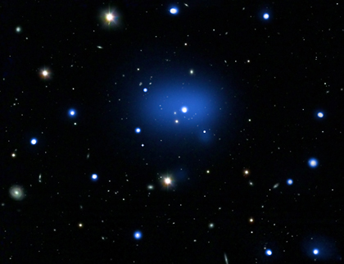
Epsilon Aurigae | JKCS041
Picture of light curve (Brightness over time). An eclipsing binary star. This is when 2 stars circle around one another, and we see them edge on. The system has a period of 27.1 years. An eclipse lasts between 640 and 730 days. | Composite image. An extremely distant galaxy cluster, about 10.2 billion years away. This object may help scientists better understand how the universe developed at an early age.

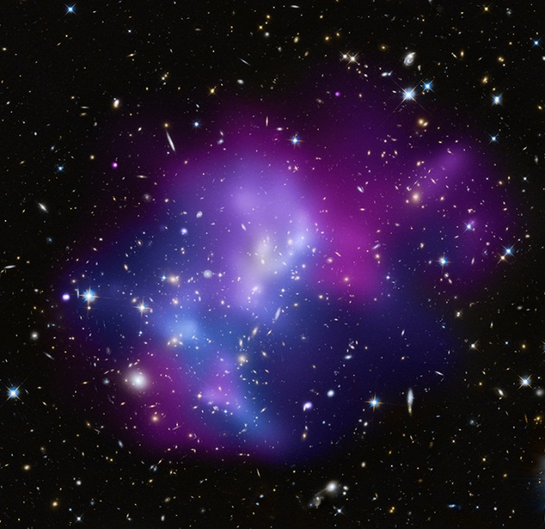 | 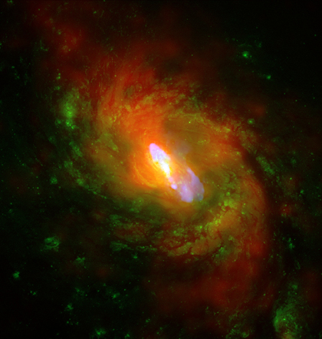
MACSJ0717.5 | NGC 1068
Composite image. 4 galaxy clusters are being involved in a collision here. Blue and purple are xray data showing location of hot gas. The cooler gas is purple. About 5.4 billion light years away. | Composite image. One of the nearest and brightest galaxies containing a supermassive black hole. Million-mile per hour wind from the black hole shapes the galaxy. X rays are red, optical green, radio blue.
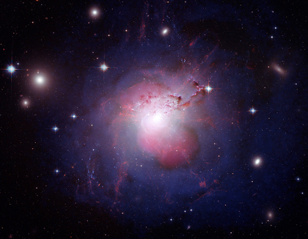 | 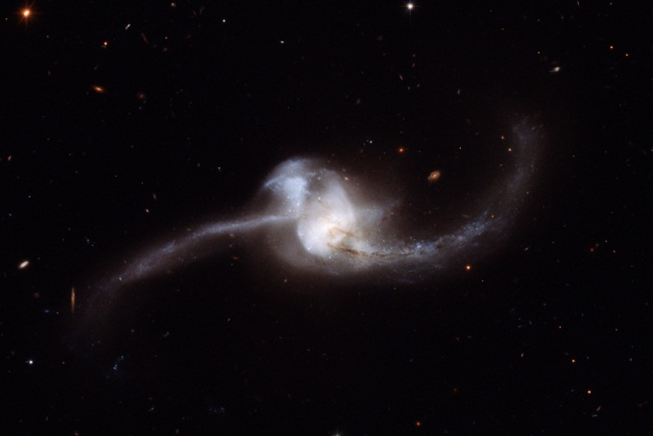
NGC 1275 (Perseus A) | NGC 2623
An active, massive galaxy. Lies at the center of the Perseus galaxy Cluster. Pink center lobes are radio, showing emission from the black hole. Blue is xray. | Galaxy merger. Coevolved galaxy merger. Core black holes have fused into one active galactic nucleus. Star formation in core and tidal arms. Reconstructing the original galaxies and how galaxy mergers happen help us understand how our universe has evolved.

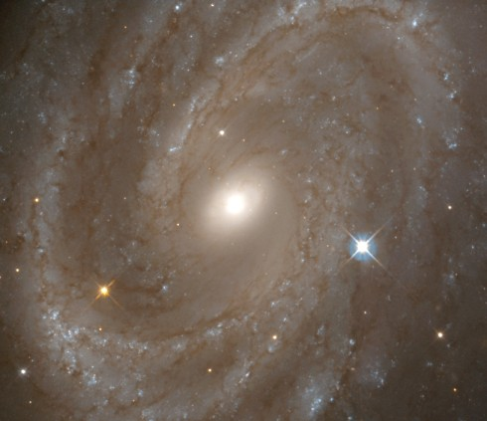 | 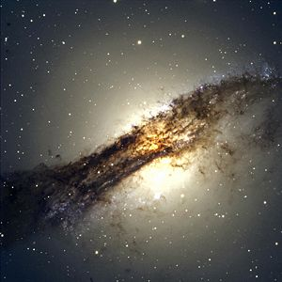
NGC 4603 | Centaurus A (NGC 5128)
Spiral galaxy 100 million light years away. Distance has been measured using 36 Cepheid variable stars. Used to help determine the hubble constant, which tells how fast the universe is expanding. | Lenticular galaxy. 10-16 million light years. Active galactic nucleus, very bright. Starburst galaxy. The black gas in front is not part of the galaxy. (It’s the white orb)
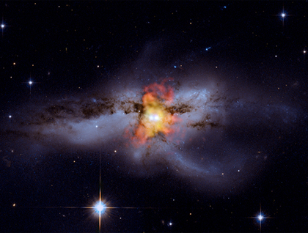 | 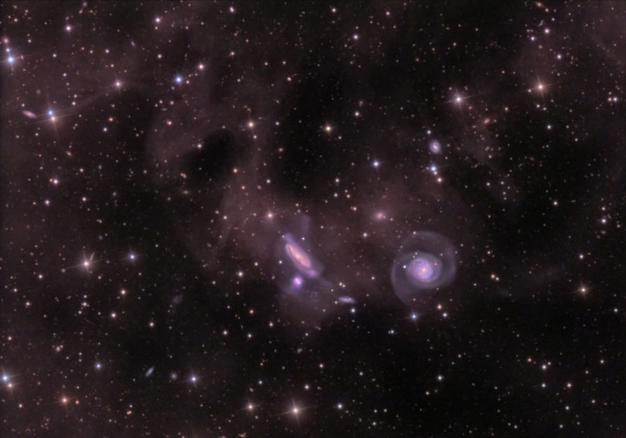
NGC 6240 | NGC 777
NGC 6240 is a galaxy that contains two supermassive black holes in the process of merging. Scientists think the merger began about 30 million years ago and will conclude some tens or hundreds of millions of years in the future. X-ray is orange thing in center, optical is the rest. | Group of galaxies 200 million light years away. They are making repeated close passages that will ultimately result in galaxy-galaxy mergers on a cosmic timescale. The interactions can be trace by galaxy distortions and faint streams of stars created by gravitational tides.

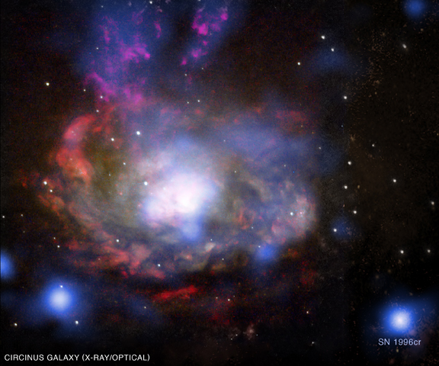 | 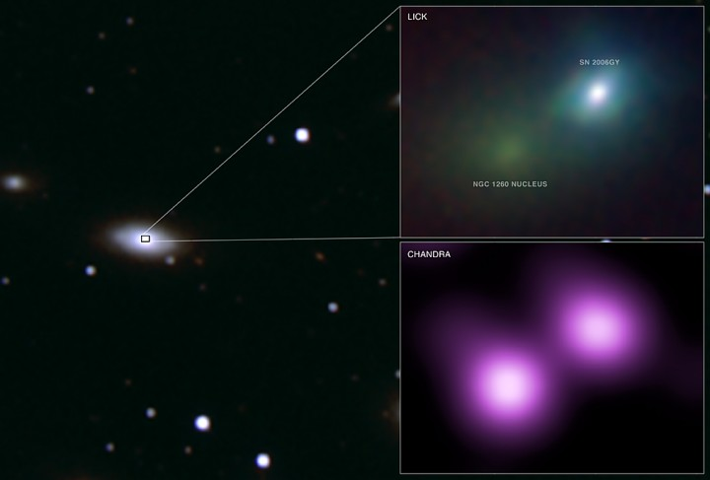
SN 1996cr | SN 2006gy
Bright blue source in bottom right is the supernova. It was discovered by searching through internet archives of 18 different telescopes. About 12 million light years away. | The brightest observed supernova, 240 million light years away. 100 solar mass star exploded due to a matter-antimatter pair instability, destroying the core and leaving no black hole or neutron star behind.
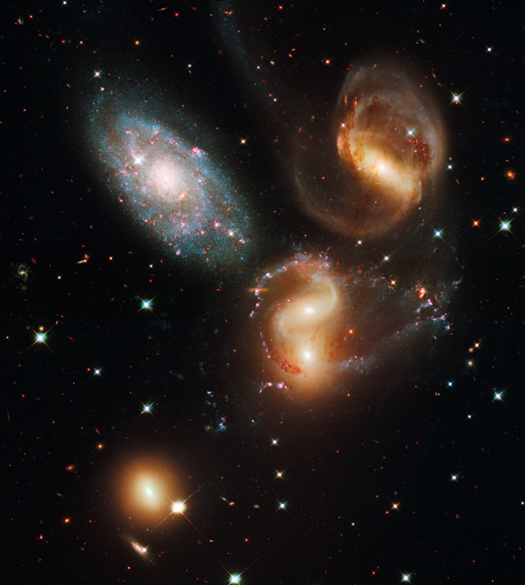 | No picture
Stephan’s quintet | H2356-309
300 milion light years away. The four yellow galaxies are interacting and twisting under the influence of gravitational tides. The blue galaxy is much closer, 40 million light years away. | A collection of extremely distant warm hot intergalactic medium, some of the “missing matter” I the nearby universe. Observed with x-rays.

